**DATA VISUALIZATION CHARTS**

|  |  |
| --- | --- |
| **Team ID** | PNT2022TMID18255 |
| **Project Name** | Corporate Employee Attrition Analytics |

**DASHBOARD 1**

**Dashboard 1 Visualizations**

**Employee Attrition**

**Attrition by Joblevel**

**Attrition by Businesstravel**

**DASHBOARD 2**

**Dashboard 2 Visualizations**

**Attrition by Salary Hike %**

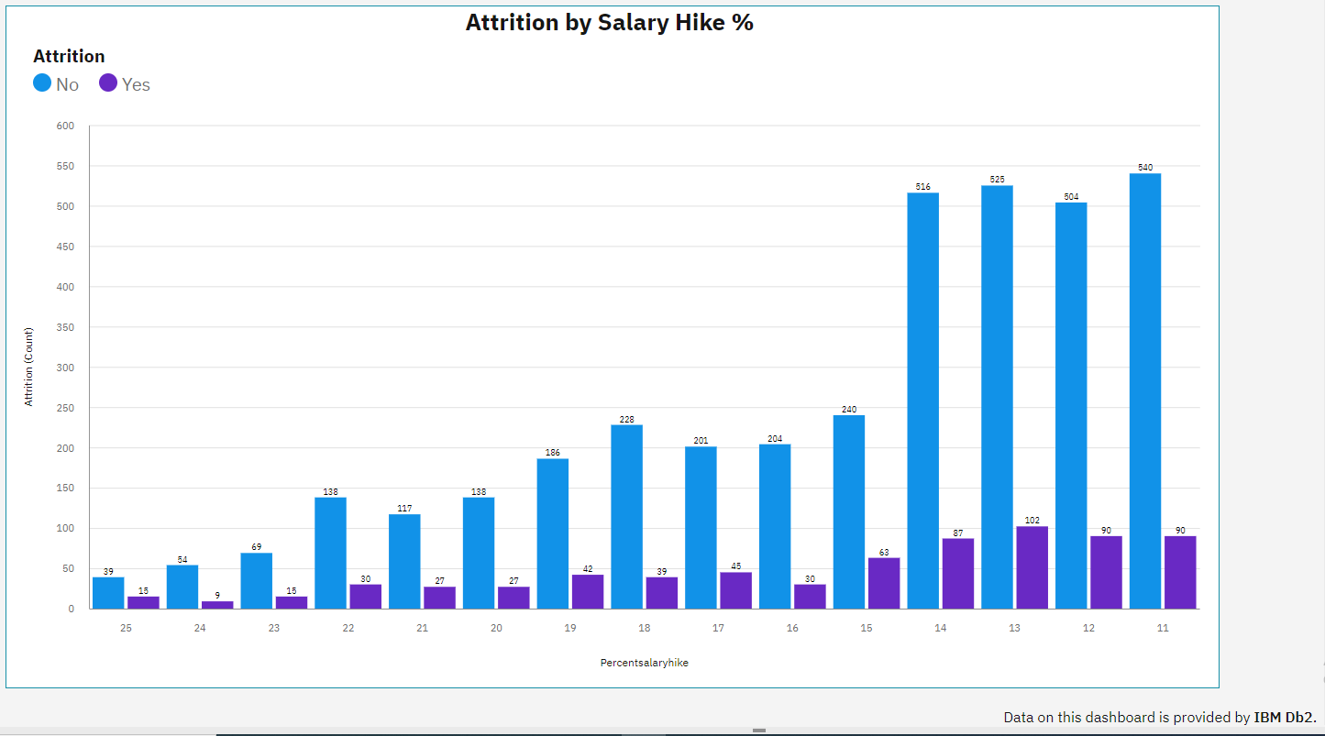

**Attrition by Experience**

**Attrition by Monthlyincome**

**Attrition by Numcompaniesworked**

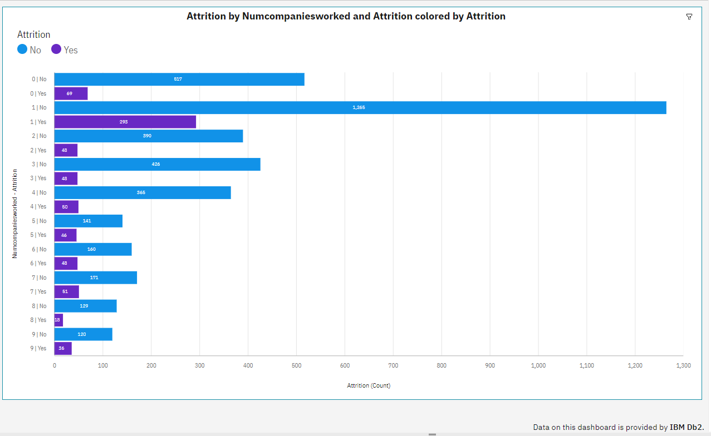

**Dashboard 3**

**Dashboard 3 Visualizations**

**Attrition by Department**

**Attrition by Jobrole**

**Attrition by Educationfield**

**Attrition by Maritalstatus**

